A000-AM,S-Peru-Wari-Olla-White-faced Ibis-Ceramic-600 CE

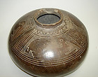

Fig. 1. AM,S-Peru-Wari-Olla-White-faced Ibis-Ceramic-600 CE

**Case No.: 14.**

**Accession No.**

**Formal Label:** AM,S-Peru-Wari-Olla-White-faced Ibis-Ceramic-600 CE

**Display Description:**

The Huari were Middle Horizon civilization in the south-central Andes and coastal Peru c 600 CE. By 600 CE the Wari encompassed the ancient oracle center of Pachacamac, which is possibly where this olla was made, ensconcing the prized white–faced ibis as part of the oracle regalia. This chocolate brown olla depicts a white-faced Ibis, a prized large bird with brown plumage with a greenish shine, which is featured in four panels around the opening of the olla. This bird id known for its religious significance in many cultures and it may have had spiritual significance for the Wari as well.



Fig. 2. White-faced Ibis after http://www.world-birds.com/files/comworld-birds/database/photo-threskiornithidae-plegadis-chihi-5122_largecrop.jpg

Pachacamac, located in the Lurin Valley, may have been in use as a sacred oracle site from the 1st millennium BCE while its settlement began sometime in the early 1st millennium CE. The god Pachacamac, also known as the ‘Maker of the Earth’, was a creator god who was also associated with earthquakes. In coastal mythology, Pachacamac had defeated the rival creator god Con who had stopped all rainfall as punishment for humanity’s wickedness.

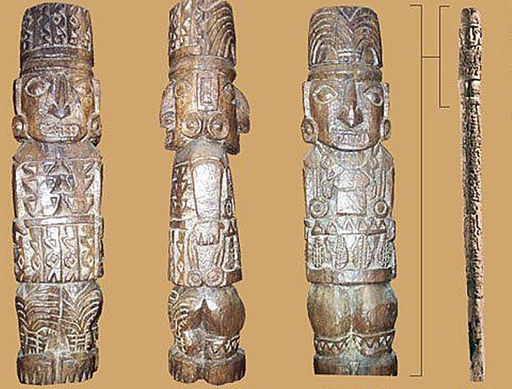

Gog Pachacamac after <http://www.ancientpages.com/wp-content/uploads/2018/05/pachacamacsite15.jpg>

Pachacamac then changed the existing human race into animals and created a whole new race of men and women. In some versions of the myths the god sent four stars to earth, the two male stars became the kings and nobility while the two female stars became the commoners.

The god’s sacred wooden statue was worshipped at the site, situated inside a large temple complex built on a stepped earthen platform. This structure is contemporary with the Moche and Nazca civilizations (200 BCE – 600 CE). Built overlooking a colonnaded plaza and sitting on an eight-level platform on a natural hill, the temple buildings must have dominated the site. Each level of the adobe brick platform is around one meter high, and they were painted in bright colors with plant and animal designs. The figures were made more striking by outlining them in black. A set of artist’s brushes (of human hair and reeds) and a bag of pigments were found buried at the site in 1935 CE. The temple was well-maintained as some areas of decoration show as many as 16 re-coats. Buildings on the highest platform were arranged around a courtyard, and some were used as accommodation.

The site attracted pilgrims from far and wide to consult its oracle although just how this functioned is not known in detail. We know that a High Priest interpreted the oracle from the privacy of a chamber only he was permitted to enter. Pilgrims had to undergo many weeks of initiation, fasting and cleansing rituals before they could be considered worthy of consulting the oracle. They were also expected to make offerings such as foodstuffs, coca, textiles, and any other precious goods they could afford. Indeed, the priests of Pachacamac established a network of subsidiary shrines throughout the region which extracted tributes from local populations. As at ancient oracles the world over, questions posed would have concerned the weather for agricultural purposes, warfare, health issues, family problems, and so on.

Such was the popularity of the site that the historian Alden Mason described Pachacamac as ‘the Mecca of Peru’. This is attested by the finds in tombs of pottery and textiles coming from many different cultures such as the Lambayeque, Nazca, Wari, Tiwanaku, and Chimu. Eventually, the religious buildings spread with many shrines to lesser deities and a residential area sprang up to cover an area of 4 square miles (c. 10 square km). It thus became the largest center in central and southern Peru. In the residential zones many of the floors and column bases, which must have supported roofs of matting, survive.

**LC Classification: F3430.1.H83**

**Date or Time Horizon: 600 CE**

**Geographical Area: Pachacamac**

**Map:**

**GPS coordinates:** [12°15′24″S 76°54′01″W](https://tools.wmflabs.org/geohack/geohack.php?pagename=Pachacamac&params=12_15_24_S_76_54_01_W_type:landmark)

**Cultural Affiliation: Wari**

**Media: ceramic**

**Dimensions: Dia 9 in**

**Weight:**

**Condition: original**

**Provenance:** Culturalpatina Fairfax Station, VA, US AP47102

**Discussion:**

**References:**